Why Cherry Pick?

* It can help in applying changes committed in wrong branch accidently.
* Apply some changes from other branch to your branch.
* If merge is not possible due to incompatible versions of the branches.

Steps for Cherry pick

1. git checkout <branch name from which we have to pick commit from>.
2. git log - To get the commit reference of the commit you have to pick.
3. git checkout <branch name to which commit has to be applied>.
4. git cherry-pick <commit reference>.

Other option in git cherry-pick command

-n or --no-commit : Brings the changes of the commit to the staged area of current branch but no commit it.

-e or --edit : Lets you edit the commit message prior to commit.

-x : Appends a line “(cherry picked from commit … )” to the original commit message, indicating from where commit is picked from. Only for the commits cherry-picked from public branch.

**-n or --no-commit**  
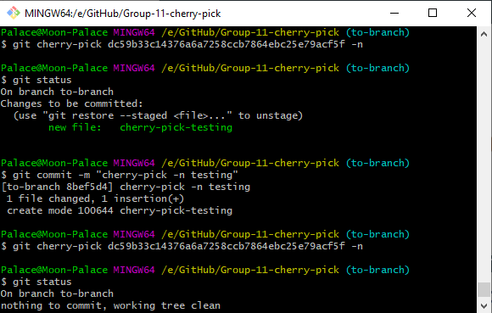

-e or –edit

